**Project Design Phase**

**Solution Architecture**

|  |  |
| --- | --- |
| Date | 15 February 2026 |
| Team ID | LTVIP2026TMIDS81736 |
| Project Name | LearnHub: Your Center for Skill Enhancement |
| Maximum Marks | 4 Marks |

**Solution Architecture:**

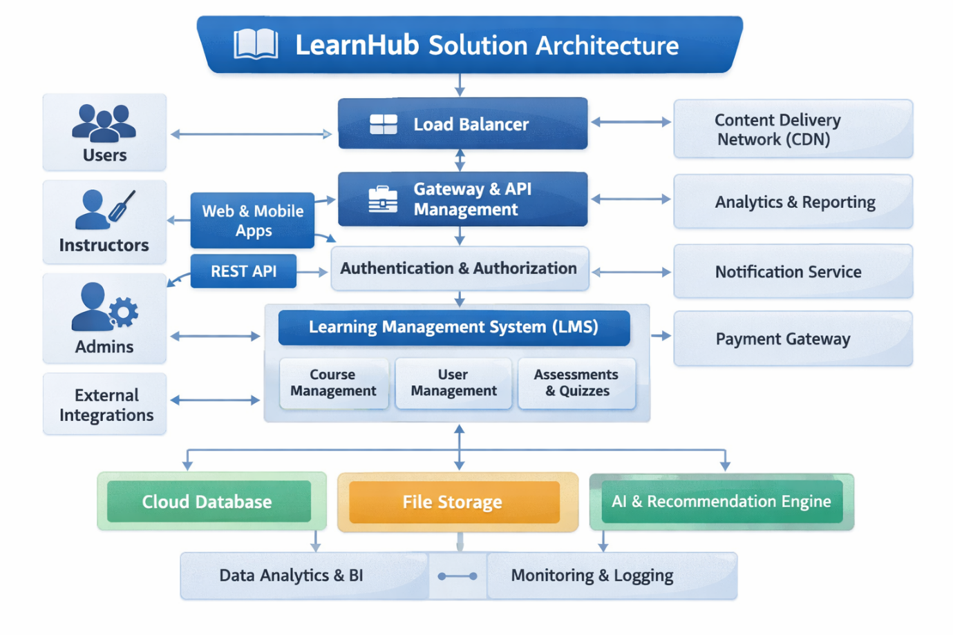

*Figure-1: Architecture and data flow of the LearnHub course enrollment enrolling platform*